Homework 3

STAT:3210 Experimental Design and Analysis

Yubing Li



**1. Problem 3.7:**

**(a) ANOVA:**

**H0:** mixing techniques do not affect the strength of the cement vs.

**Ha:** mixing techniques affect the strength of the cement

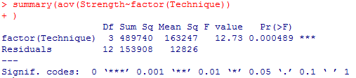

Since the p-value is 0.0005, which is smaller than α level = 0.05, we reject the null hypothesis and say there’s sufficient evidence to show that the mixing techniques affect the strength of the cement.



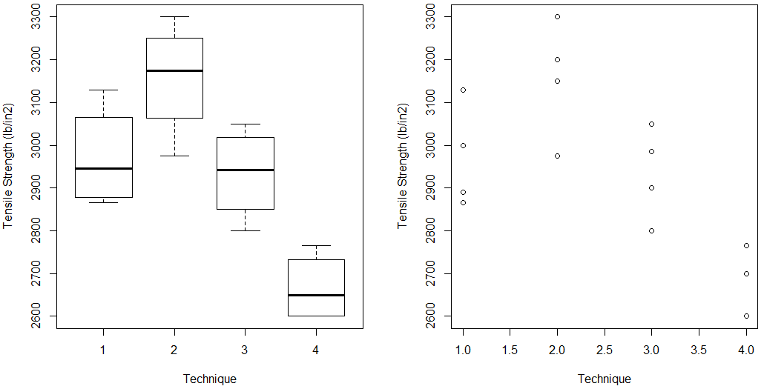**(b) Plots:**

**(c) LSD: (R output on the next page)**

H0: the selected two model means are equal vs. Ha: the means are not equal.

The p-value for technique 1 vs. 3 is 0.65014, the only one that is larger than the α level = 0.05. Therefore, we conclude that we cannot reject the null hypothesis for 1 vs 3 but reject for 1 vs 2, 1 vs 4, 2 vs 3, 2 vs 4 and 3 vs 4. In general, the technique 1 vs. 3 is not significantly different. All other pairs significantly different.

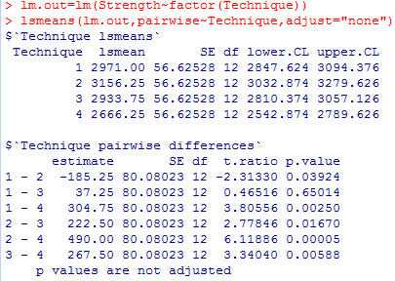

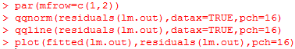**(plots for (d) and (e))**

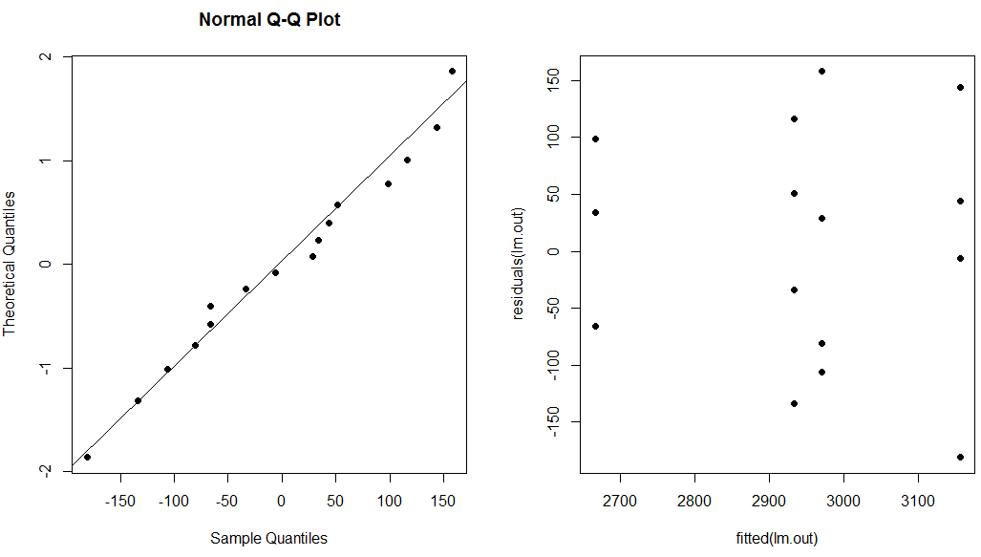

**(d) Normal plot: (left one)**

Since the outcomes are mapping closely to the diagonal reference line, without any outliers, we conclude that the normal assumption is valid.

**(e) Residuals vs. predicted: (right one)**

Since the residuals are normally distributed for corresponding fitted outcome and there’s no unusual figures in the plot, the constant variance assumption is not violated.

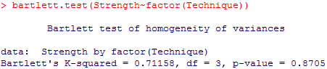**(f) Test Equal Variance:**

We test the null hypothesis that the variances are all equal. Since the p-value is large, we cannot reject the null hypothesis and say the equal variance assumption is valid.

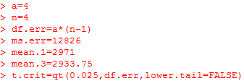**(g) One-at-a-time Interval:**

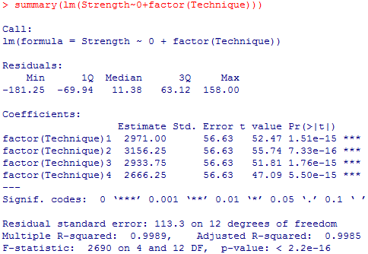



The 95% CI on difference in means between tech1 and tech3 is (-137.22, 211.732). Since the interval contains 0, we conclude that the means for these two techniques can be the same. It’s consistent with the test result in part (c) that 1 vs 3 is not significantly different.

**2. Problem 3.8:**

**(a) Tukey HSD**

H0: for all pairwise means vs. Ha: not H0.

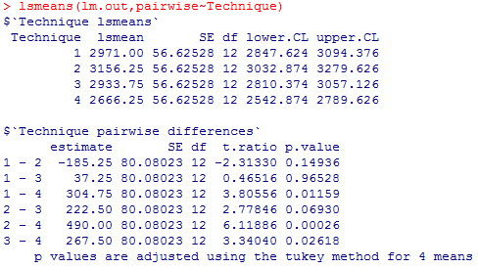

The p-values in HSD are adjusted. The result for Fisher LSD and HSD not same, the p-value for 1 vs 2, 1 vs 3, 2 vs 3 are less than 0.05. We cannot reject the null hypothesis and consider their paired means are not significantly different. We reject the null hypothesis for the rest paired means and conclude they are significantly different. In LSD test, we only conclude 1 vs 3 is not significantly different.

**(b)** In Fisher LSD, we use t statistic to do the comparison. However in Tukey HSD, we use Studentized Range distribution to obtain the p-values, which override the result of unadjusted p-values by using adjusted ones.

**(c) Bonferroni:**

H0: for all pairwise means vs. Ha: not H0.

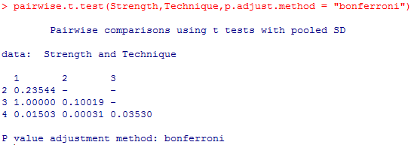

Since only the last row of the p-values are smaller than 0.05, we cannot reject the hypothesis for 1 vs 2, 1 vs 3, 2 vs 3 and conclude they are not significantly different. And reject the null hypothesis for 1 vs 4, 2 vs 4 and 3 vs 4 and conclude their paired means are significantly different.

**(d) Bonferroni vs Tukey HSD:**

The test results are the same for Bonferroni test and Tukey HSD test. However, in Bonferroni, the experiment-wise error rate is at most α while in Tukey, it’s exactly α. Bonferroni test is more conservative than Tukey HSD.



**3. Problem 3.26:**

**(a) ANOVA:**

H0: the means are equal vs. Ha: at least one mean is not equal to others

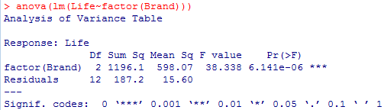

Since the p-value is 6.141*10-6, which is smaller than 0.05, we reject the null hypothesis and conclude there’s at least one brand of batteries’ life is different.

**(b) Assumptions:**

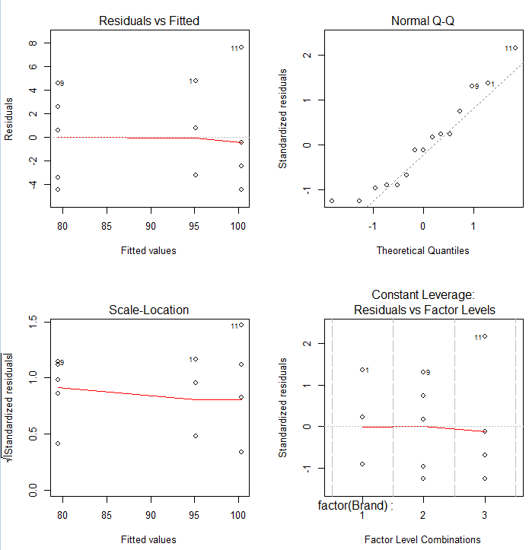

i) Independence: the dataset is completely randomly collected, it’s valid.

ii) Normality: In upper right plot, we can see the outcomes are generally close to the diagonal reference line without extreme outliers, the normality assumption is valid.

iii) Constant variance: the residuals are normally distributed for each corresponding fitted value. There’s no unusual figure in upper left plot. Therefore, the constant variance assumption is valid.

**(c) Contrasts:**

i)H0: vs. Ha:

ii) H0: vs. Ha:

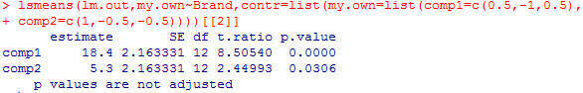

i) Since the p-value = 0, is smaller than 0.05, we reject the null hypothesis and conclude the average mean lives of 1 and 3 is different from mean life of 2.

ii) Since the p-value = 0.03 is smaller than 0.05, we reject the null hypothesis and conclude the mean lives of 1 is different from the average mean lives of 2 and 3.

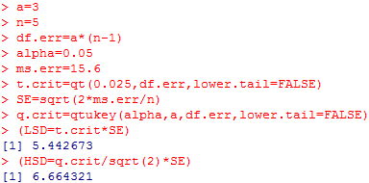**(d) LSD and HSD:**

i) Fisher LSD: Fisher LSD is 5.4427.

For every paired mean difference that is larger than 5.4427, we conclude that pair has significant difference. The comparison-wise error rate is 0.05.

ii) Tukey HSD: Tukey HSD is 6.6643.

For every paired mean difference that is larger than 6.6643, we conclude that pair has significant difference. The experiment-wise error rate is 0.05.

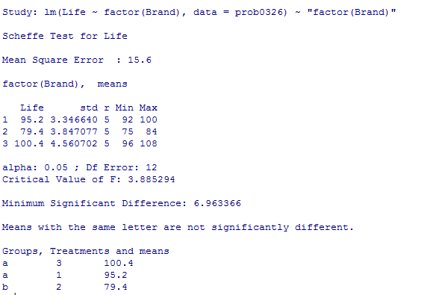

**(e) Scheffe:**

H0: vs Ha:

MSD is 6.96337.

Since 1 and 3 has same letter, we know that they are not significantly different.

On the other hand, the mean life of batteries for 1 and 2, 2 and 3 are significantly different.

The experiment-wise error rate is 0.05 for all pairs.

**(f) Dunnett:**

H0: vs Ha: for i = 2, 3

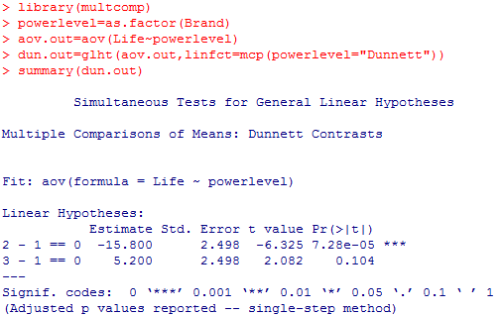

The p-value for comparison 1 and 2 is smaller than 0.05. We reject the null hypothesis and say there’s significant difference between the mean life of batteries of 1 and 2.

The p-value for comparison 1 and 3 is smaller than 0.05. We cannot reject the null hypothesis and say there’s no significant difference between the mean life of batteries of 1 and 3.

The family-wise error rate is 0.05 when performing multiple comparisons of treatment group with control of brand 1.